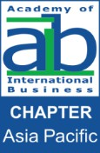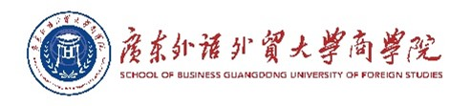

2024 Academy of International Business Asia Pacific Regional Conference
“Re-imagine International Business: Accelerate Growth through
Collaboration and Digital Transformation”

Contacts
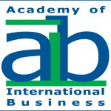
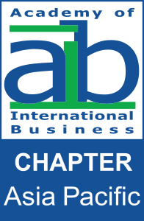

Academy of International Business (AIB)
Phone: (1) 517 432 1452
Fax: (1) 517 432 1009
Email: aib@aib.msu.edu
Homepage: https://www.aib.world/

AIB Asia Pacific Regional Chapter
Homepage: https://sbus.hsu.edu.hk/en/aib/chapter- information

School of Business
The Hang Seng University of Hong Kong (HSUHK)

Phone: (852) 3963 5651
Email: marvislee@hsu.edu.hk
Homepage: https://sbus.hsu.edu.hk/en/

The Research Institute for Business (RIB)
Homepage: https://rib.hsu.edu.hk/

Page 1

